RIHAM AHAMED ABDUL RAHEEM

HND COMPUTING IDM

Network princIPLES

Contents

**PHYSICAL AND VIRTUAL ADDRESSING** 1

Role of a physical address, functionality and limitations 1

Role of a virtual address, functionality and limitations 1

Relationship & differences between IP and MAC addresses 2

**Network Topology** 3

Physical topology in computer network. 3

**Bus Topology** 3

**Ring Topology** 4

**Star Topology** 5

Logical topology in computer network. 6

**Broadcast topology** 6

**Token topology** 6

**NETWORK MODELS** 7

**REFERENCES** 9

**List of figure**

Figure 1: MAC Address 1

Figure 2: BUS topology & nodes 3

Figure 3: Ring topology & Nodes 4

Figure 4: Star topology & nodes 5

**List of tables**

Table 1: IP address & MAC Address 2

Table 2: Advantage & disadvantage of Bus topology 3

Table 3: Advantage & disadvantage of Ring topology 4

Table 4: Advantage & disadvantage of Star topology 5

Table 5: OSI Model and TCP/IP Model 7

# **PHYSICAL AND VIRTUAL ADDRESSING**

## Role of a physical address, functionality and limitations

In general IT, a physical address refers to either some memory location, identified as a series of a binary number or a media access control address. However for the scope of this report, a physical address refers to the Media Access Control address (MAC) of a computer which may be a unique identification related to the network adapter (Network Interface Card) that's wont to identify a computer during a network.

This address is employed both by hardware and software for accessing data. For software, however, there's no direct use of the physical address; instead it uses a virtual address to access memory. A hardware unit inside the pc system referred to as the Memory Management Unit (MMU) is solely liable for translating virtual address to physical address and the other way around . A protocol called Address Resolution Protocol (ARP) is liable for converting these addresses during a network.

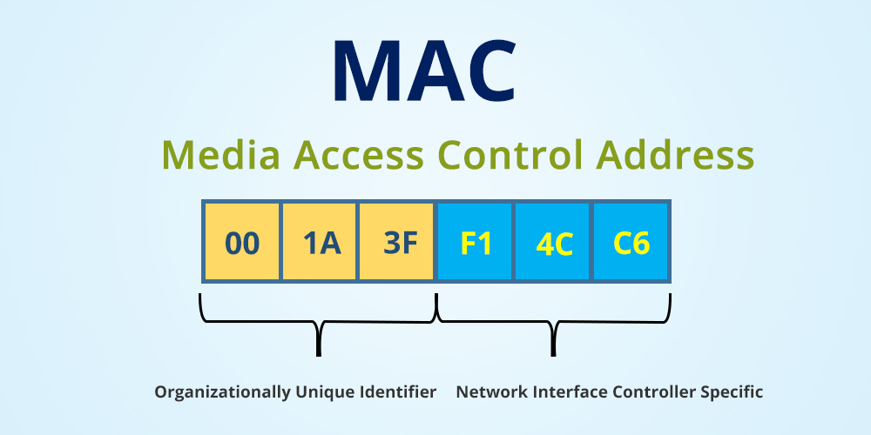

Figure 1: MAC Address

## Role of a virtual address, functionality and limitations

A virtual address generally refers to a memory pointer to a specific memory that a OS has allowed a process to use. However in networking a virtual address generally refers to the IP address, short for the web protocol address that the pc system will use to speak with other members of the network, IP addresses are crucial during a network as when there's a necessity to transfer or send data from one place to a different , you would like a source and destination address. The IP address is employed to define these 2 addresses.

IP addresses achieve many tasks that a computing system just cannot with a MAC address, it allows networks to speak with other networks, retrieve and send data to and from devices that aren't computers etc. one among the most important achievements of the existence of IP addresses is that the Internet.

## Relationship & differences between IP and MAC addresses

Table 1: IP address & MAC Address

|  |  |
| --- | --- |
| Internet Protocol Address | Media Access Control Address |
| IP Address stands for Internet Protocol Address. | MAC Address stands for Media Access Control Address. |
| IP Address is either four byte (IPv4) or six byte (IPv6) address. | MAC Address is a six byte hexadecimal address. |
| A device attached with IP Address can retrieve by RARP protocol. | A device attached with MAC Address can retrieve by ARP protocol. |
| Internet Service Provider provides IP Address. | NIC Card’s Manufacturer provides the MAC Address. |
| IP Address is the logical address of the computer. | MAC Address is used to ensure the physical address of computer. |
| IP Address operates in the network layer. | MAC Address operates in the data link layer. |
| IP Address identifies the connection of the device on the network. | MAC Address helps in simply identifying the device. |
| IP Address modifies with the time and environment | MAC Address of computer cannot be changed with time and environment. |
| IP Address can be found by third party. | MAC Address can’t be found easily by third party. |

# **Network Topology**

Network Topology refers to the layout of a network and how different nodes in a network are connected to each other and how they communicate.

Topologies are either **physical** (the physical layout of devices on a network) or **logical** (the way that the signals act on the network media, or the way that the data passes through the network from one device to the next).

## Physical topology in computer network.

There are many physical topologies in network.

1. BUS Topology
2. RING Topology
3. STAR Topology

### **Bus Topology**

Alternatively referred to as a line topology, a bus topology is a network setup where each computer and network device is connected to a single cable or backbone. Depending on the type of computer network card, a coaxial cable or an RJ-45 network cable is used to connect them together.

The Bus topology transmits data only one direction.

Figure 2: BUS topology & nodes

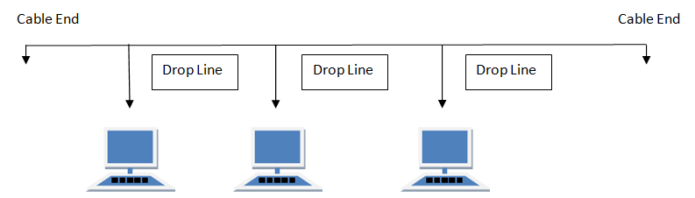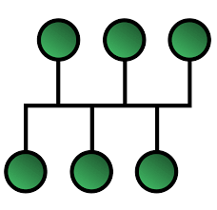

Table 2: Advantage & disadvantage of Bus topology

|  |  |
| --- | --- |
| ADVANTAGE | DISADVANTAGE |
| * Used in small networks. | * Cable has a limited length. |
| * It is easy to understand. | * It is slower than the ring topology. |

### **Ring Topology**

It is called ring topology because it forms a ring as each computer is connected to another computer, with the last one connected to the first. Exactly two neighbors for each device.

Features of ring topology

* A number of repeaters are used for Ring topology with large number of nodes, because if someone wants to send some data to the last node in the ring topology with 100 nodes, then the data will have to pass through 99 nodes to reach the 100th node. Hence to prevent data loss repeaters are used in the network.
* The transmission is unidirectional, but it can be made bidirectional by having 2 connections between each Network Node, it is called.

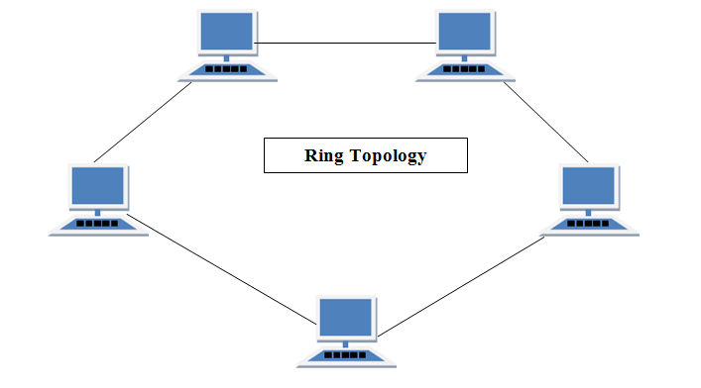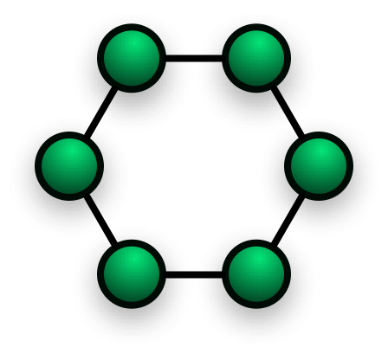

Figure 3: Ring topology & Nodes

Table 3: Advantage & disadvantage of Ring topology

|  |  |
| --- | --- |
| ADVANTAGE | DISADVANTAGE |
| * Transmitting network is not affected by high traffic or by adding more nodes, as only the nodes having tokens can transmit data. | * Failure of one computer disturbs the whole network. |

### **Star Topology**

In this type of topology all the computers are connected to a single hub through a cable. This hub is the central node and all others nodes are connected to the central node.

Features of star topology

* Every node has its own dedicated connection to the hub.
* Hub acts as a repeater for data flow.
* Can be used with twisted pair, Optical Fibre or coaxial cable.

Figure 4: Star topology & nodes

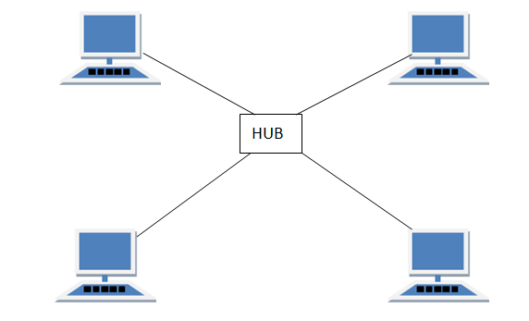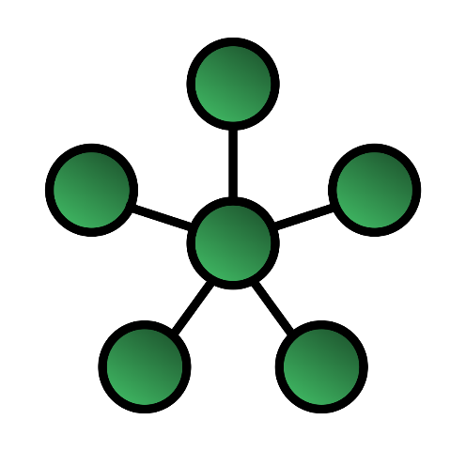

Table 4: Advantage & disadvantage of Star topology

|  |  |
| --- | --- |
| ADVANTAGE | DISADVANTAGE |
| * Fast performance with few nodes and low network traffic. | * Cost of installation is high. |
| * Hub can be upgraded easily. | * Expensive to use. |
| * Easy to troubleshoot. | * If the hub fails, then the whole network is stopped because all the nodes depend on the hub. |

## Logical topology in computer network.

The logical topology of a network determines how the hosts communicate across the medium. The two most common types of logical topologies.

1. Broadcast topology
2. Token topology

### **Broadcast topology**

The use of a broadcast topology indicates that each host sends its data to all other hosts on the network medium. There is no order that the stations must follow to use the network.

### **Token topology**

The second logical topology is token passing. In this type of topology, an electronic token is passed sequentially to each host. When a host receives the token, that host can send data on the network. If the host has no data to send, it passes the token to the next host and the process repeats itself. Two examples of networks that use token passing are Token Ring and Fiber Distributed Data Interface (FDDI). A variation of Token Ring and FDDI is Arc net. Arc net is token passing on a bus topology.

# **NETWORK MODELS**

The most known and common network principles known to networking are the OSI model and the TCP/IP model. Below in the table a full comparison of the protocols, networking concepts and solutions have been described.

Table 5: OSI Model and TCP/IP Model

|  |  |
| --- | --- |
| Open Systems Interconnection Model | Transmission Control Protocol/Internet Protocol Model |
| * It is a theoretical model primarily used for computer systems. * Consists of 7 main layers. * Developed by International Standard Organization. * Usage is pretty low. * Follows a vertical approach * The transport layer in the OSI model guarantees the successful delivery of packets. * The OSI model has separate presentation and session layers. * Transport and network layers are compulsorily connection oriented. * OSI is mostly a guidance tool for learners in the networking field. * The OSI model is vague in terms of including protocols into the model as at times 1 protocol functions in multiple layers. * Protocols are easily changed in the OSI model as technology advances. * The OSI model defines interfaces, services and protocols used clearly and are also protocol independent. * The physical layer that performs media, signal and binary transmission uses 802.11, DSL, SDH, V.34, RJ45 and RS-232 protocols. * The data link layer that performs physical addressing uses Ethernet, 802.11, MAC/LLC, HDP, Fiber Channel, Frame relay, HDLC, PPP, Q.921 and Token ring protocols. * The network layer that performs path determination and logical addressing uses IP, ARP, IPsec, ICMP, IGMP and OSPF protocols. * The transport layer that performs end to end connections and reliability uses TCP, UDP, SCTP, SSL and TLS protocols. * The session layer that performs inter-host communication uses TCP, SIP, RTP and RPC-named pipes. * The presentation layer that performs data representation and encryption uses HTML, DOC, JPEG, MP3, AVI and sockets. | * It is a client to server based model for transmission of data over the internet. * Consists of 4 main layers. * Developed by Department of defense. * Usage and implementation is frequent. * Follows a horizontal approach * The TCP/IP model there is no guarantee that packets will be delivered successfully but it is more reliable than OSI. * TCP/IP model does not have such separate layers. * Transport layer and network layers are both connection & connection less oriented. * The TCP/IP model could be called the implementation of the OSI model. * The TCP/IP model does not have such a problem. * Replacing or introducing a new protocol is not easy. * TCP/IP is protocol dependent and there is no clear differentiation between interfaces and protocols. * Have a combined layer for data link and physical called network access layer that uses Ethernet, token ring, ATM or frame relay protocols. * Network layer is called internet layer, and performs the function uses ARP, IP, IGMP and ICMP protocols. * Transport layer uses TCP and UDP protocols. * Application, presentation and session layer are combined and are called the application layer, and uses HTTP, SMTP, Telnet, FTP, DNS, RIP, SNMP etc. protocols. |

From the above as you notice, the OSI model is conceptual and therefore cannot be implemented in the real world. Therefore I wish to implement the TCP/IP model while basing my network per the OSI model’s standards and layered architecture.

# **REFERENCES**

GeeksforGeeks, (2020). Introduction of MAC Address in Computer Network [online], viewed 18 March 2020, Available at: <https://www.geeksforgeeks.org/introduction-of-mac-address-in-computer-network/>

Studyyonight, (N/D). Types of Network Topology [online], viewed 18 March 2020, Available at: <https://www.studytonight.com/computer-networks/network-topology-types>